Make sure that you have installed:

1. Python 3.7 (www.python.org/downloads/)

2. PyCharm Community Edition (www.jetbrains.com/pycharm/download/)

**Python Session 1**

Course overview:

1. Data types, variables and operations 2. Input, loops and functions

3. If statements

4. Lists and dictionaries

5. Files, modules and APIs

6. Project planning and group project 7. Group project

8. Group project and presentations

Instructor Introductions

Put a coloured Post-It note on the back of your laptop monitor during exercises:

Red/pink: I need instructor support

Green: I do not need instructor support

Topics this session:

1. Run Python with les and console

2. Recognise data types (Integers, Floats and Strings) 3. Identify different maths operations

4. Understand Error Messages

5. Use variables in your programs

PyCharm

**Why Python?**

***Programming Language:*** *A language with a set of rulesthat are used to communicate instructionsto a computer*

***Program:*** *A set of instructionsthat are run by a computer*

Human languages are used to communicate between people

Programming languages are used to communicate instructions from people to computers

Python:

1. Designed to be readable

2. Wide selection of 3rd party libraries 3. Popular

4. Open Source

**Your rst Python Program**

Open PyCharm and click Create New Project



Call the project cfg-python

Under Project Interpreter: New Virtualenv environment , set Base interpreter to Python 3.7

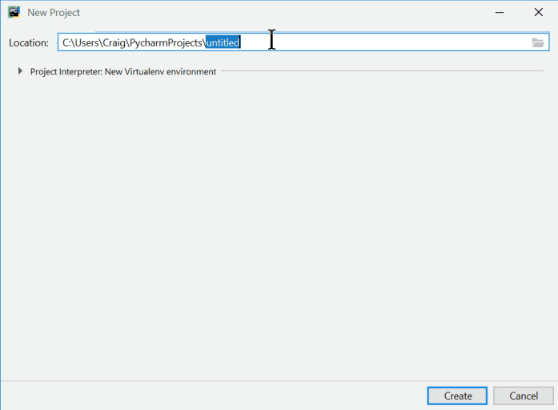

Right click on cfg-python > New > Python File

Name the le hello ( .py is added automatically)

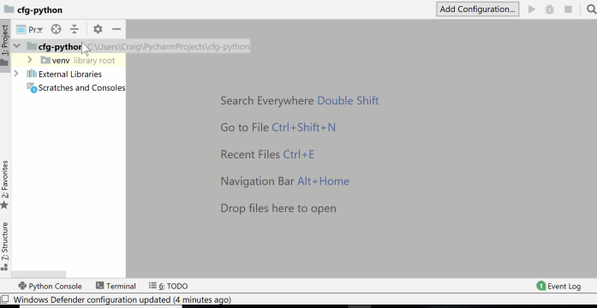

Add this code to hello.py print('Hello, World!')

Right-click in your new le > Run 'hello'

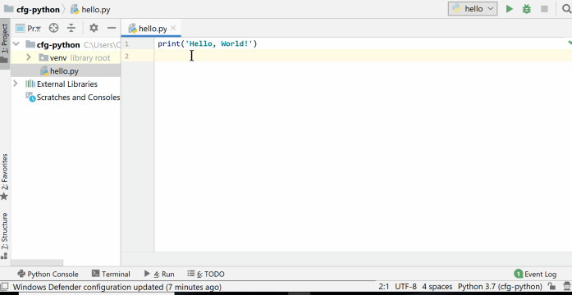

��Congratulations!��

You've just run your rst Python program

**Function:** A reusable piece of code that completes a specic task

You can recognise a function as they are a word followed by round brackets () e.g. print()

The print() function is used to output a message to the programmer You can change the data given to the function to change the output

print('I hope it is sunny this weekend')

**Exercise 1.1:** Now that you've run your rst program, try the following:

Change the message to anything you want

Repeat the code on multiple lines to output several messages

Find out what happens when you remove different parts of the code (e.g. brackets)

Don't worry if something unexpected happens. Think about what you changed and why it might have caused it to happen.

**Numbers and Operators in Python**

**Integer:** a Python **data type** for **whole numbers**. For example 5 , -99 and 1048 are all integers. **Float:** a Python **data type** for **decimal numbers**. For example 5.6 , 9.0 and -67.1001 are all oats.

Opening the Python Console

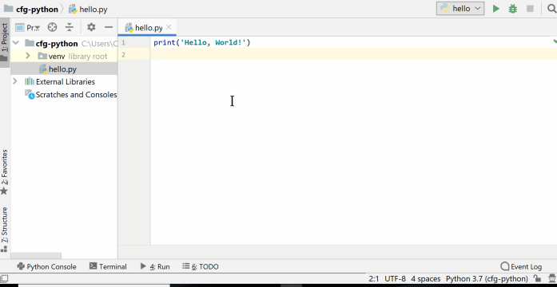

**Exercise 1.2:** Type these lines into your **Python console**:

5 - 6

8 * 9

6 / 2

5 / 0

5.0 / 2

5 % 2

2 * (10 + 3)

2 ** 4

What does each one do and what is its output? Are there any outputs you didn't expect?

Subtraction:

5 - 6

Multiplication: 8 * 9

Division:

6 / 2

Division by zero: 5 / 0

Float division:

5.0 / 2

Modulo (remainder):

5 % 2

Brackets:

2 * (10 + 3)

Exponent (x to the power of y) 2 ** 4

Operator types

+: add

-: subtract

*: multiply

/: division

**: exponent

%: modulo (remainder)

**Python Console**

There are two main ways to write and run Python programs:

1. With les

2. On the Python console (also called the shell)

**Python File Python Console** Runs all lines from top-to-bottom Runs one line as it is entered Only shows output when using print() Shows output for every line For code that will be ran multiple times Interactive for exploration

**The String Data Type**

**String:** a Python data type for **text** and **characters**.

For example 'Hello' , "abcdef1234" and 'cats' are all strings

Strings must be written between a pair of single or double speech marks '...' or "..."

"This is a string"

'This is also a string'

Forgetting the speech marks

hello

Will cause this exception

Traceback (most recent call last): File "<stdin>", line 1, in <module> NameError: name 'hello' is not defined

To x it add speech marks "hello"

The * and + operators work on strings as well as integers. Let's investigate what they do

**Exercise 1.3:**

In your **Python console** type each of these

"Cat"

"Cat" + " videos"

"Cat" * 3

"Cat" + 3

"Cat".upper()

"Cat".lower()

"the lord of the rings".title()

What is the output for each one and why?

One of them causes an exception. Read the exception message. What do you think it means?

Results:

"Cat"

"Cat" + " videos"

"Cat" * 3

"Cat" + 3

"Cat".upper()

"Cat".lower()

"the lord of the rings".title()

1. The + operator can join two strings together, this is called **concatenation** 2. The * operator repeats a string a number of times

3. .upper() , .lower() and .title() are **methods**

**method:** A repeatable piece of code that completes a task for specic data-type

Methods are like funcitons, but they are tied to a specic data-types e.g. .upper() can only used with a string and not an integet or a oat

Running this code

print("Cat" + 3)

Will cause this exception

Traceback (most recent call last):

File "<stdin>", line 1, in <module>

TypeError: can only concatenate str (not "int") to str

Putting a number in str() converts it to a string print("Cat" + str(3))

**Variables**

**Variable:** a reusable **label** for a data value in Python

Creating (assigning) a variable has three parts:

1. The variable's name

2. An equals sign =

3. The data value it references

username = 'sarah_1987'

age = 23

variable name

value

Values and variables are interchangeable

A variable can be put anywhere that a data value can be used

print('spaghetti')

food = 'spaghetti'

print(food)

Variables can be reused. This program calculates the cost of 12 oranges.

oranges = 12

cost_per_orange = 0.5

total_cost = oranges * cost_per_orange

print(str(oranges) + " oranges")

print("costs " + str(total_cost))

The oranges variable is reused twice in the program

**Exercise 1.4:** In a new Python **le** called cat_food.py , create a program that calculates how many cans of cat food you need to feed 10 cats

Your will need:

1. A **variable** for the number of **cats**

2. A **variable** for the number of **cans** each cat eats in a day

3. A print() function to output the result

**Extension:** change the calculation to work out the amount needed for 7 days

An Example Solution

cats = 10

cans = 2

total_cans = cats * cans

output = str(cats) + " cats eat " + str(total_cans) + " cans" print(output)

Extension Solution

cats = 10

cans = 2

days = 7

total_cans = cats * cans * days

msg = str(cats) + " cats eat " + str(total_cans) + " cans in " + str(days) + " days" print(msg)

**String Formatting**

Python strings have a method ( .format() ) that substitutes place-holders {} for values

oranges = 12

cost_per_orange = 0.5

total_cost = oranges * cost_per_orange

output = "**{}** oranges costs £**{}**".format(oranges, total_cost)

print(output)

This could have been written as:

oranges = 12

cost_per_orange = 0.5

total_cost = oranges * cost_per_orange

output = str(oranges) + " oranges costs £" + str(total_cost) print(output)

**Exercise 1.5:** Rewrite cat_food.py to use string formatting instead of joining strings with + . An example of string formatting:

user_name = 'sarah_1987'

age = 23

output = '**{}** is **{}** years old'.format(user_name, age)

print(output)

Solution

cats = 10

cans = 2

total_cans = cats * cans

output = "**{}** cats eat **{}** cans".format(cats, total_cans) print(output)

**Comments**

**Comment:** a way for a programmer to write human-readable notes in their code. When running a program, comments are ignored by Python.

# This is a comment

Comments in Python start with a #

# A program to calculate the cost of some oranges

oranges = 12

cost_per_orange = 0.5

total_cost = oranges * cost_per_orange

output = "**{}** oranges costs £**{}**".format(oranges, total_cost) print(output)

**Recap**

1. Run Python with les and console 2. Data types (Integers, Floats and Strings) 3. Maths operations

4. Understanding Error Messages 5. Variables

**Question 1:** What are the names of the maths operators?

**Question2:** InwhatsituationshouldyouuseaPythonleandwhenshouldyouusethePython Console?

**Question 3:** What is the output of this code?

days = 31

hours = "24"

total_hours = days * hours

msg = "There are **{}** in **{}** days".format(total_hours, days) print(msg)

**Homework:** Session 1 homework questions in your student guide